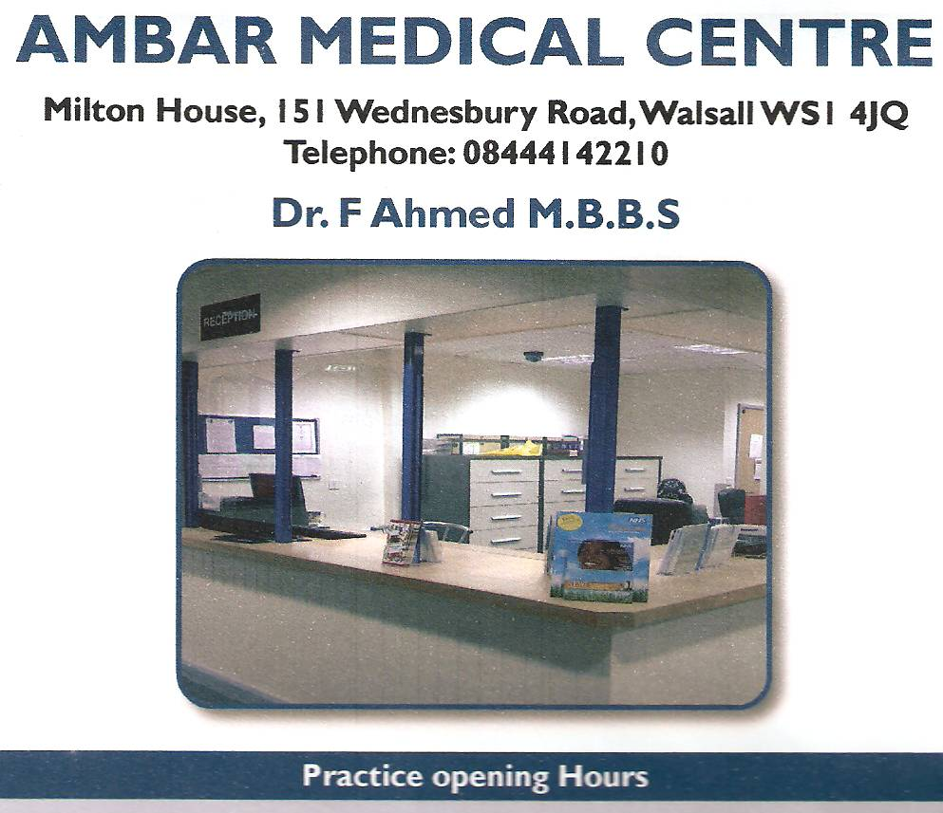

# **The Saddlers Health Centre**

**www.thesaddlershealthcentre.co.uk**

Dr Farogh Mahmood

Dr Minaxi Verma

**133 Hatherton Street**

**Walsall**

**WS1 1YB**

**TELEPHONE: 01922 622326**

**PRACTICE OPENING HOURS**

|  |  |
| --- | --- |
| **MON** | **8:00 TILL 18:30** |
| **TUE** | **8:00 TILL 18:30** |
| **WED** | **8:00 TILL 18:30** |
| **THU** | **8:00 TILL 18:30** |
| **FRI** | **8:00 TILL 13:00** |

***Please note, surgery phone lines are closed Tuesday to Thursday 13:00 – 16:00pm. Any URGENT matters patients can call our South 1 PCN on 01922 660721 anything NONE URGENT please call the surgery after 4pm.***

Milton House, 151 Wednesbury Road, Walsall WS1 4JQ

Telephone 01922 626300

Dr H Lodhi MBBS MRCGP

**Monday to Thursday: 8.30am – 6.30pm**

**Friday: 8.30am – 12pm**

**DOCTOR MORNING SURGERY TIMES**

**Dr Verma:** Monday 9:30am – 12.30 pm

Tuesday 9:30am – 12.30 pm

Wednesday 9:30am – 12.30 pm

Thursday 9:30am – 12.30 pm

Friday 9:30am – 12.30 pm

Dr Mahmood Monday 9:00am – 12.00 pm

Tuesday 9:00am – 12.00 pm

Wednesday 9:00am – 12.00 pm

Thursday 9:00am – 12.00 pm

Friday 9:00am – 12.00 pm

**EVENING SURGERY TIMES**

Dr Verma: Monday 13:30pm – 14:30 pm

Tuesday 17:00pm – 6:00 pm

Wednesday 17:00pm – 6:00 pm

Thursday None

Friday None

Dr Mahmood Monday 16:50pm – 17:50pm

Tuesday None

Wednesday 13:30pm – 14:30pm

Thursday 16:50pm – 17:50pm

Friday None

**PRACTICE NURSE SURGERY TIMES**

Monday 08:00am – 16:30pm

Tuesday 10:30am – 18:30pm

Wednesday 08:00am – 16:30pm

Thursday 10:30am – 18:30pm

Friday 8:00am – 1:00 pm

**HEALTHCARE ASSISTANT SURGERY TIMES**

Tuesday 08:00am – 13:00pm

Thursday 08:00am – 17:30pm

We also have availability through our PCN (Primary Care Network) for extended hours they are Monday – Thursday 18:30 – 20:00 Saturday 09:00 – 17:00 speak to one of our reception staff to arrange one of these appointments.

- - - - - - - - - - - - - - - - - - - - - - - - - - - - - - -

**ANTENATAL CLINICS**

Antenatal clinics are held by Practice Midwife, every other Monday morning. All pregnant ladies will be seen from 8 weeks of pregnancy. Appropriate antenatal care is given as per NICE guidelines, which includes Blood Tests, Leaflets and information (in relevant languages) Guidance, awareness (including Breast Feeding, Postnatal care and Postnatal Depression.) Clinics held 09:00am – 12pm.

**TO REGISTER AS A PATIENT**

Any person wishing to register with the Practice please see reception for a registration form and process. You can also register as a patient on line just visit [www.thesaddlershealthcentre.co.uk](http://www.thesaddlershealthcentre.co.uk)

If you do not live within the catchment area, this will be assessed by the GP on individual basis, who will decide whether the application is clinically appropriate. Patients registered outside of catchment will not be entitled to home visits, and also may affect other services such as Pharmacy deliveries. You can also register as a patient on line.

**OTHER SOURCES OF HELP**

Walsall Urgent Care Centre is located in the Manor Hospital.

NHS 111

Walsall Talk Therapies – 0800 953 0995

Samaritans: - 116 123

Domestic Abuse helpline: 01922 649569

**ZERO TOLLERANCE**

The NHS operates a zero tolerance policy with regards to violence and abuse and the practice has the right to remove violent patients from the list with immediate effect in order to safeguard practice staff, other patients and other persons. In some cases, the police will be called.

**We ask that you treat the Practice Staff with courtesy and respect – we are here to help you.**

Violence in this context includes actual or threatened physical or verbal abuse which leads to fear for a patient’s / member of staff safety.

**FRIENDS AND FAMILY TEST**

The NHS friends and family test (FFT) is an important opportunity for you to provide feedback on the care and treatment you receive and to improve services. Our aim is to provide high quality care for all, now and for future generations. All feedback is anonymous. Please request a Friends and Family test form from reception, or visit our web site on [www.thesaddlershealtc](http://www.thesaddlershealtc)entre.co.uk to complete. We also conduct in house surveys we would be very grateful if you would complete this when visiting the surgery.

NHS Choices:

We do send a text message to all patients that have been seen at the surgery to ask them to kindly complete a review on our NHS choices if you would like to receive a text please speak to the surgery.

**PRACTICE NURSE CLINICS (Jointly with HCA)**

Chronic Disease Management (Asthma/COPD, Diabetes, Hypertension, CHD, Epilepsy, Hypothyroidism, Cancer, CKD, Learning Disabilities).

Spirometry, Well person clinics, Contraception, Smoking Cessation, Obesity Clinics, BMI, Weight Management, Travel clinics

Ear Syringing, Urine Test e.g. Diabetes.

**REGISTATIONS**

Any person within the catchment area will be given a New Patient pack, which includes a New Patient questionnaire to complete, together with a GMS1 form, an ethnicity form, and a Practice leaflet. You can also visit our website to register on line.

The surgery will require proof of identity and address.

The Practice is an equal opportunities employer, and this also relates to treatment and registration of our patients. The Saddlers Health Centre policy is to ensure that no person or persons, whether patients, visitors or employees, receive less favourable treatment on the grounds of gender, marital status, disability, race, colour, nationality, ethnic or national origins, social class, age, religion, sexual orientation, appearance or medical condition. Where a person in disabled the practice will attempt to comply with the duty to make reasonable adjustments. There is Disabled access to the building, plus disabled facilities.

The practice will do its utmost to ensure that all persons are treated fairly, and that the practice environment is free from discrimination and harassment.

Any person already known to the practice may be refused if they are known to be abusive or violent.

The Saddlers Health Centre follows best practice, therefore all children (i.e. under 18’s) need to be registered with maternal parent (i.e. mother – exceptional circumstances considered)

The final decision will be made by the GP. All patients accepted to the practice will need to attend surgery to see our Practice Nurse for a new patient check. (No new patient check is required for under 16’s).

New babies are registered via birth certificate, red book.

We can also arrange a interpreter to attend your appointment if you first language is not English please speak to the reception staff when booking your appointment so that this can be arranged. Please note this is NOT for urgent appointment as it takes at least 24 hours to arrange an interpreter so please bring a English speaking person with you if you have an urgent appointment. Please note you will require a double appointment so there is enough time arranged for you consultation.

**MINOR ILLNESS PHARMACY SCHEME**

**PHARMACY FIRST** is a scheme for managing minor illness for patients who are registered at the centre. The scheme aims to speed up access to health services for people with minor ailments by enabling those who wish to be seen by a community pharmacist.

If you have a **headache, sore throat, temperature, earache, cough, diarrhoea, cold and flu,** **head** **lice, hay fever or dry skin/simple eczema**, please speak to a member of our reception team who can refer you to the minor illness clinic at participating pharmacies.

**HOME VISITS**

If you think a home visit is necessary, please contact the surgery as early as possible (before 10.00am) by phoning on **01922 622326**

The receptionist will ask for some details to allow the doctor to assess the urgency of the call. Please do not ask for visits if you can come to the surgery. Home visits should be regarded as a service for the genuinely housebound or seriously ill.

Home visits take up a great deal of doctor time. Doctor can normally see approximately four patients in the time it takes to visit one.

Transport problems are not considered to be a valid reason to request a home visit. It is suggested that it may be appropriate to use services of Ring and Ride 0330 053 8136 or private taxi.

**OUT OF HOURS**

If you think you need to speak to some one and it cannot wait until the surgery is next open, the **OUT OF HOURS SERVICE** can be reached on **111**, or contact you can visit the urgent care centre based at Walsall Manor Hospital.

This service is G.P. supported, and is available from Monday to Thursday 6.30pm to 8.00am; and Friday from 1.00pm onwards, all day Saturday, Sunday and Bank Holidays. **PLEASE DO NOT WAIT UNTIL MONDAY MORNING FOR URGENT TREATMENT – PLEASE CONTACT PRIMECARE OUT OF HOURS.**

If you need some general health advice or information, you can phone **NHS111**on **111** – THESE CALLS ARE FREE

**IF YOU THINK YOUR CONDITION IS LIFE THREATENING OR VERY SERIOUS, PLEASE DIAL 999**

**URGENT APPOINTMENTS**

The GP will identify the necessity for urgent appointments. We will ensure that for all necessary cases, urgent appointments will be given at the practice within 24 hours.

For any medical advice you can also ring **NHS** **Direct on 111 (24 Hours).**

Any patient needing urgent treatment outside of surgery hours, please call the out of hours NHS111 service  **ON 111**.

**For EMERGENCIES only – please use A & E Department or Ring 999. This is for seriously ill patients with Injuries and serious complaints (e.g. chest pain).**

**SURGERY POLICY FOR BREAKDOWN IN GP/PATIENT RELATIONSHIPS**

Appropriate actions will be taken against the patient failing to take advice or misuse of services.

**MISSING / CANCELLING APPOINTMENTS**

Please attend your appointment on time. If you cannot keep an appointment, please inform the surgery as soon as possible – 24 hours notice is required to enable a cancelled appointment to be offered to other patients in need and avoid disappointment to many.

We have around 1100 not attended appointment per year, if you continuously do not attend arranged appointments we will discuss your registration with the GP and take appropriate action.

**REPEAT PRESCRIPTIONS REQUESTS**

Repeat prescriptions are ordered by using the right side of your previous prescription

only. Please make sure that you have ticked all items required. This must be done through your pharmacy or by placing the request in the prescription box located at the front of the surgery or inside the reception area of the surgery.

Please allow 48 hours (2 working days) when ordering prescriptions and make

allowances for weekends and public holidays.

Plan in advance and request the repeat prescription approx 3 days before the medication

is about to finish.

Please do not insist for repeat prescriptions on the same day.

Please note: we cannot accept repeat prescription requests over the telephone as errors

can occur.

Prescriptions can be collected Monday to Thursday 10am--6.30pm, on Friday 8.30am-12pm or simply register with a pharmacy so that the prescriptions can be sent electronically.

**PATIENT’S RIGHTS AND RESPONSIBILITIES**

You are expected to follow protocols and procedures in place at the practice

You are responsible for being considerate to other patients and staff and any other personnel and property.

You are responsible for ordering prescriptions in time and administrating medication

To confirm that you understand the treatment being provided and course of action.

You are responsible for informing us about all treatments and interventions that you are involved in.

You are responsible for informing the practice if you are leaving the country for any period of time, this will allow us not to send you any appointments for any medical check outstanding until you inform us of your return.

If you are under hospital care for any reason, and you have pending appointments, it is your responsibility to inform the hospital of any changes such as address, telephone numbers, cancelling and booking appointments. You must also notify surgery of any changes.

If your refusal of treatment / advice prevents us from providing care according to our ethical and professional standards, we may need to end our relationship with you after giving you reasonable notice.

**TESTS AND RESULTS**

Most blood and urine results can take anything from one week to ten working days. If there is any abnormality in the test results, the practice will contact you by telephone or text message requesting you to make an appointment with a clinician to discuss the result of any investigation. In the interest of patient confidentiality and medical ethics issues, it is the policy of the surgery not to give blood results or any other test results relating to scan, x-ray, biopsy or MRI scan, over the phone, as issues relating to identification of patients and error in giving results can occur.

**FAMILY APPOINTMENTS**

The Saddlers Health centre uses a booked appointment system for all clinics. We do not give family appointments. Each appointment is for one person only. Please do not insist to see the doctor for an accompanying patient who does not have an appointment. If you have more than one problem to discuss please ask reception staff to arrange you a double appointment as we have a ONE PROBLEM ONE CONSULTATION SLOT policy.

**BOOKING URGENT/ROUTINE APPOINTMENTS**

Appointments can be made in person at Reception or by telephone on 01922 622326 Monday to Thursday 08:00am till 18:30pm Friday from 8:00am to 13:00pm, You can also contact your GP on line by visiting our website [www.thesaddlershealthcentre.co.uk](http://www.thesaddlershealthcentre.co.uk) and click on the accurex link, you will then need to complete the questionnaire and we will respond to you via telephone or text message within 2 working days. Yu can also request sick notes and any admin queries through accurex on line.

**NON NHS SERVICES**

Certain services to our patients are not covered by the NHS.

These include some medical reports, Driving medicals various insurance forms, and certain medical examinations. The Doctor is happy to perform most services of this sort. However, there is a fee payable in line with current British Medical Association guidelines. Please ask our reception staff for details of these arrangements.

**COMPLAINTS**

In the event of a complaint regarding the service offered to you by the practice, or any situation that arises that you are unhappy with, please collect complaint form from reception or contact the Practice Manager in writing, who will investigate matters. The Manager will acknowledge receipt of your complaint within 3 working days of receipt, and will respond fully to your complaint. If the Practice needs more than 10 days to fully investigate, you will be notified. Patient can also contact NHS England Complaints via the Patient experience team on 0300 311 2233. There is a suggestion box provided in reception, if any patient wants to comment or make suggestions regarding service provided.

**PERSONAL HEALTH INFORMATION**

Information sharing will only be used for health care purposes. These include all activities that directly contribute to the diagnosis, care and treatment of an individual, and to audit the quality of the healthcare provisional service.