# **How to register onto the Walsall HAF Programme**

To register your child onto the Walsall HAF Programme, you must first have an individual **HAF code** (one for each child).

**You need a code?**

You only need one code to access all the programmes and you will only need to register once for each child. We send over 17k letters to all children that are on free school meals with a unique code and information on how to register, to each child that is eligible.

If you have not received a letter (this can happen if our information is not up to date, or circumstances have changed), you can always contact the HAF team via email:[WR4C@walsall.gov.uk](mailto:WR4C@walsall.gov.uk). If the child is eligible or you are unsure and the HAF team will then create and email the unique code.

**To register and you have not received a code?** you first need to check if they are eligible.

To be eligible, you must be between 5 and 16, ( 4 – 17 years in full time education also meet the criteria) and have one of the following:

* Be in receipt of benefit related free school meals
* Be supported by a plan, this could be Early Help, EHCP, safeguarding plan, Young carers assessment or child protection.

**Ready to register?**

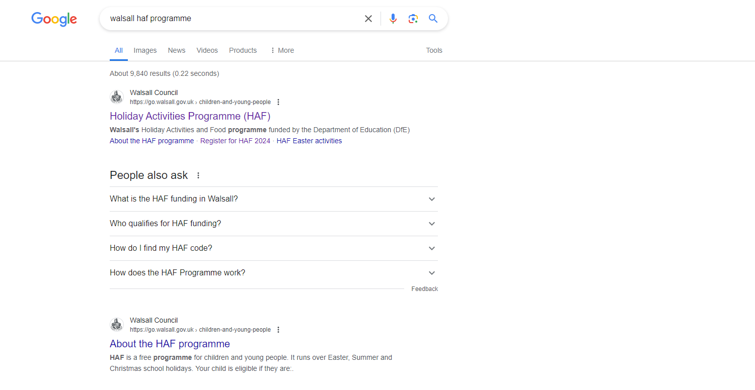Next go to **Google** or another internet search engine and type in ‘Walsall HAF’. The website will be the first result on your search.

Qr code 


You can do this or use the Walsall HAF QR code, just use the camera on your phone that will take you straight to the Register for **HAF 2024 webpage** and you are ready to register!!

A screenshot of a website for register for HAF
From here go to ‘Register for HAF 2024’ (<https://haf.walsall.gov.uk/Registration>).

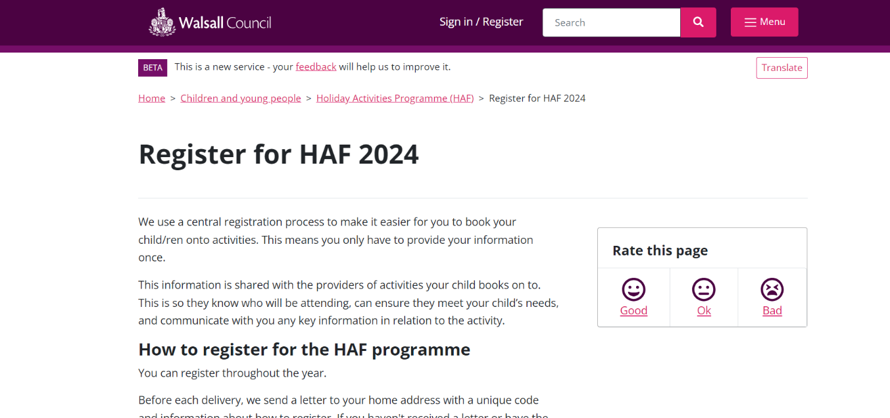Click onto it and you will go to the Register for HAF webpage (<https://go.walsall.gov.uk/children-and-young-people/holiday-activities-programme-haf/register-haf-2024>),

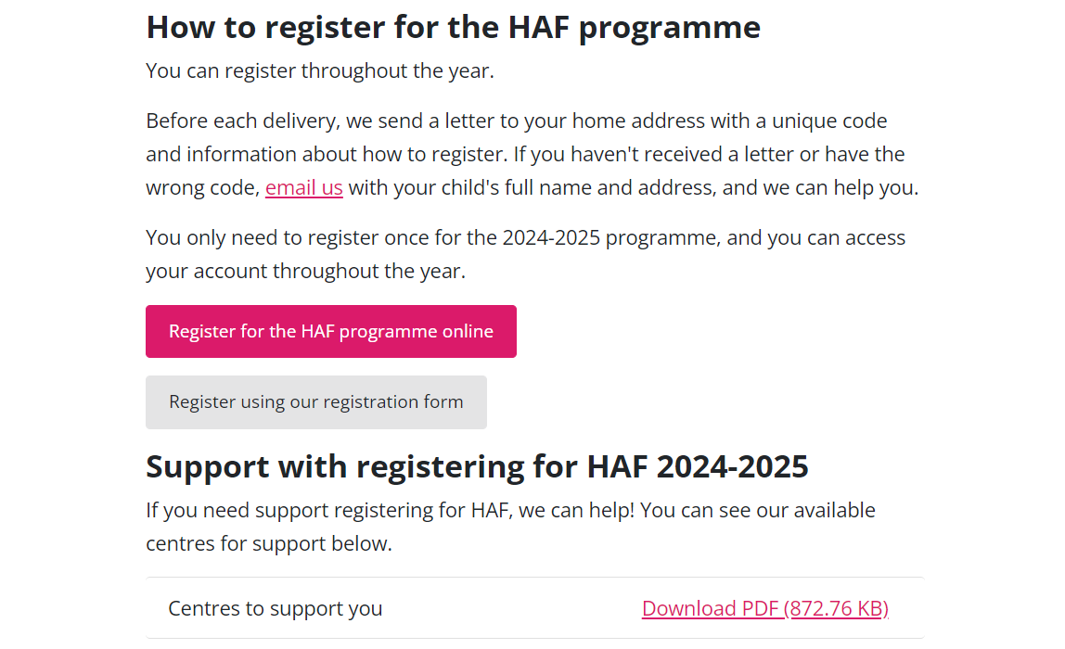

Scroll down the webpage to **‘register for the HAF programme’.**

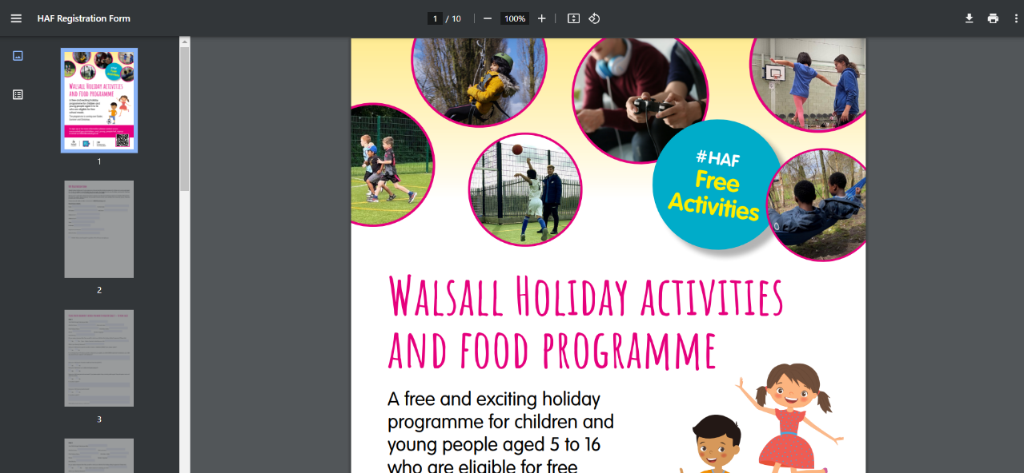You have two choices to register.

Choice 1) click ‘Register using our registration form’ to fill a form, which would be sent to the HAF team via email or post.

Choice 2) go to ‘**Register for the HAF programme online’.**

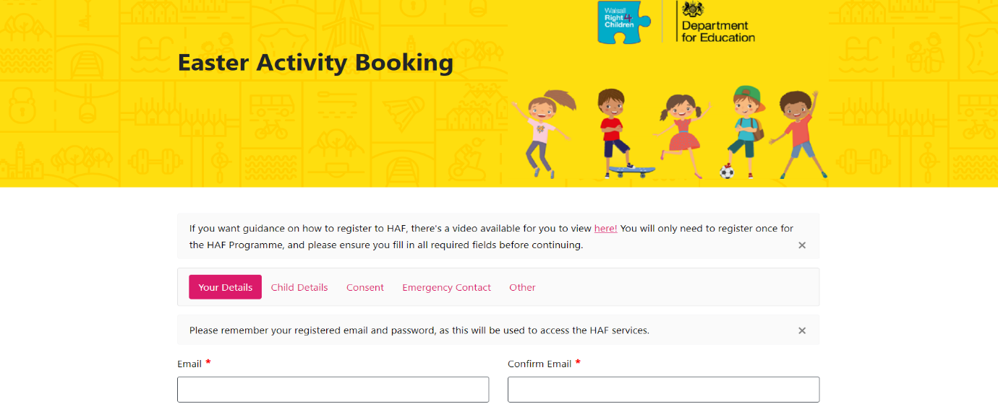On ‘Register for the HAF Programme online’, you will go to another website page.

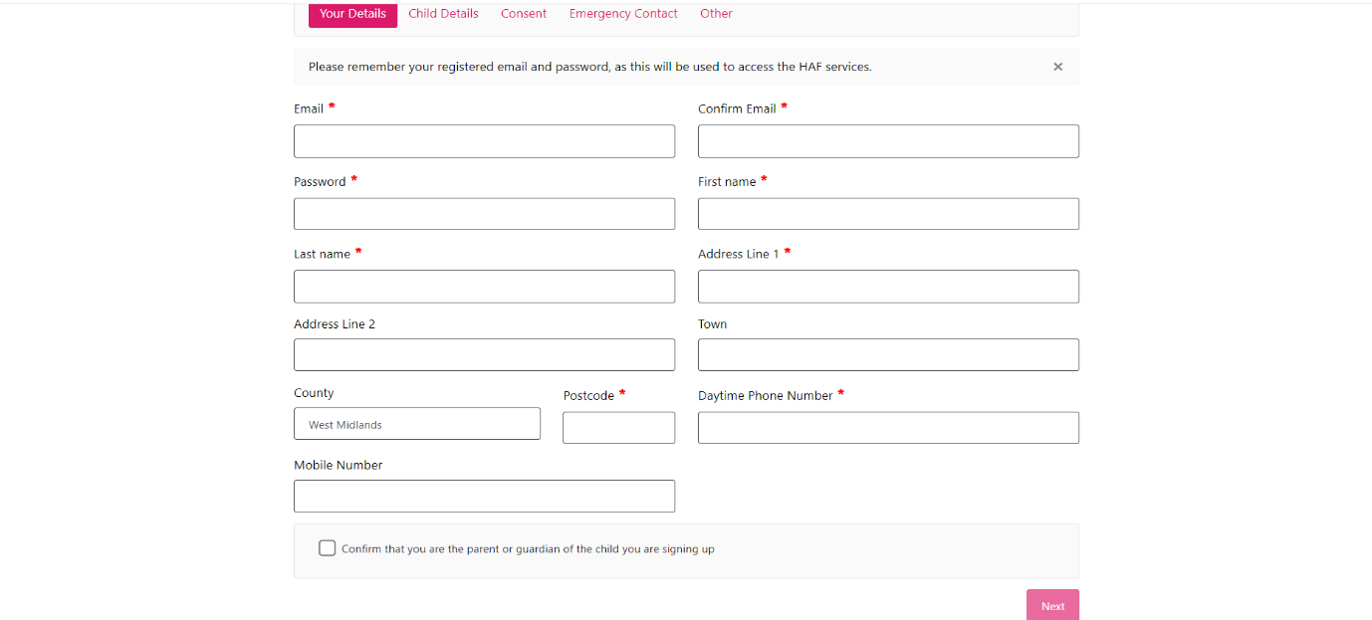Here you enter all your details, starting with your password and email address. Please follow the instructions for the password and type your full name, your full address ad contact number. Also please confirm if you are the parent or guardian of the child you’re signing up. Once this page has been completed, please click next.

You can now fill in the details for your child / children. First, please enter the amount of children you wish to sign up and start filling their details in starting with their unique HAF code.

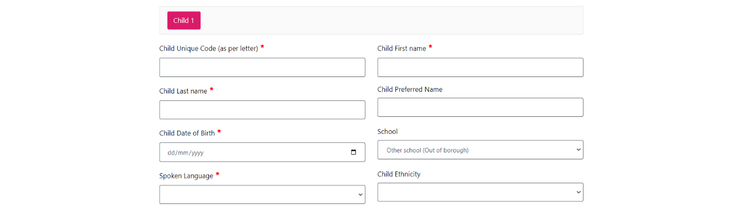

Whilst filling in, please confirm if you would like someone else to pick your child up giving their name and security password. Also confirm if your child has any additional needs, giving as much information about this as possible.

If you are unable to provide or attach information, you can send this **directly to the provider when you have booked a place.**

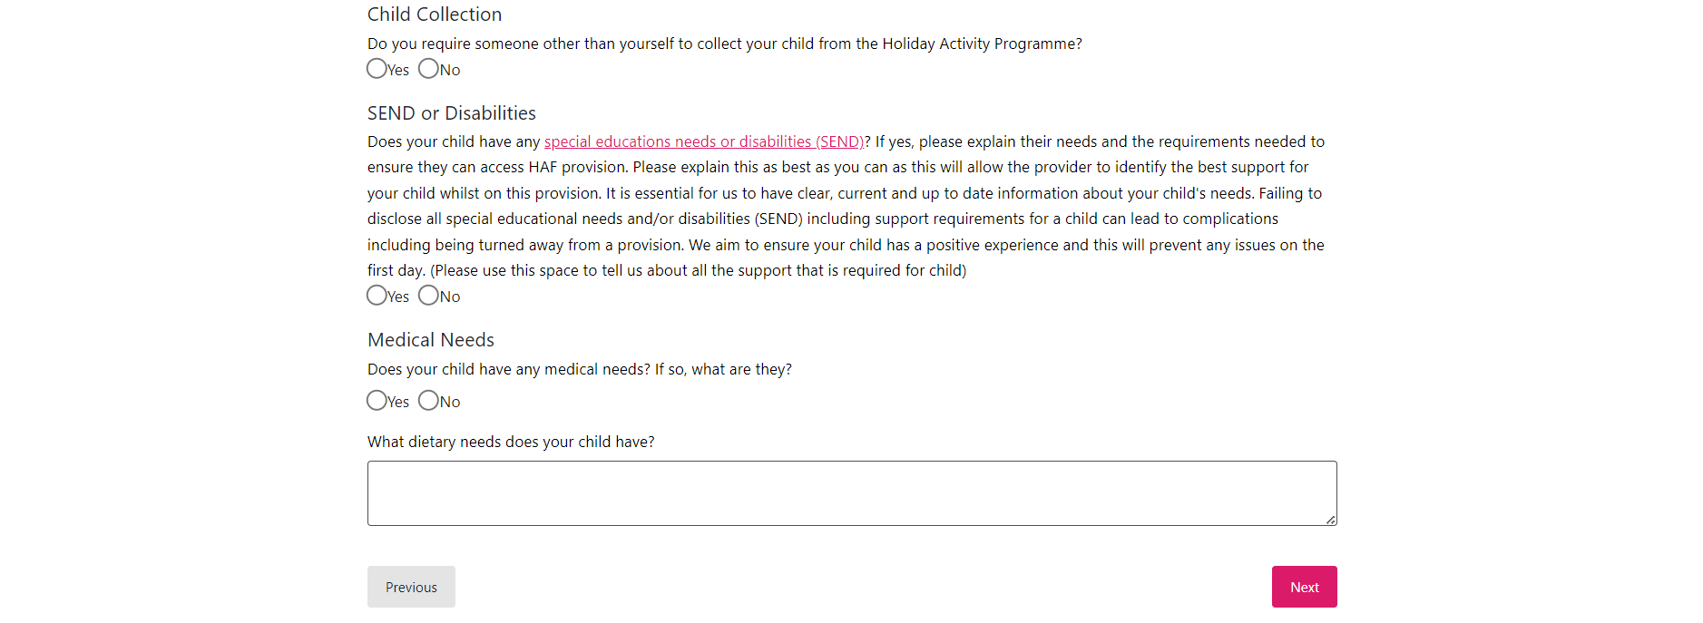Also, please confirm if your child has an education, health & care plan (EHCP), an up-to-date short breaks passport, any personal needs, medical needs and dietary requirements.

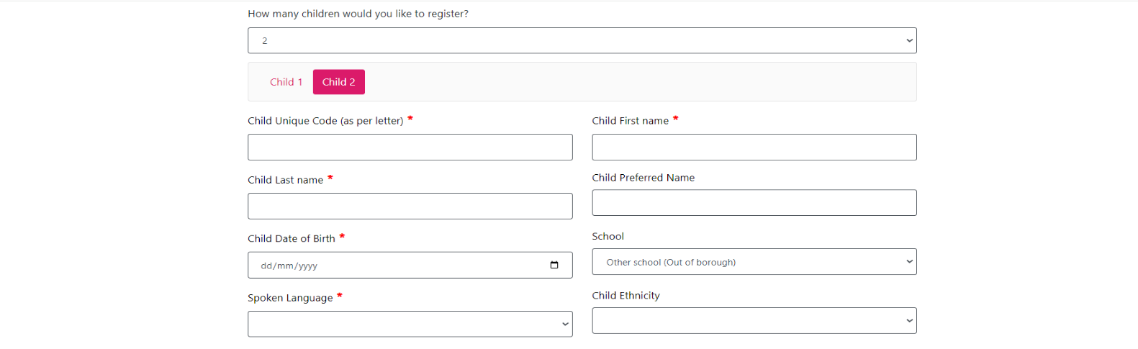Once this has been completed click next. **This will go to child 2 and repeat the same process as mentioned (this will then go to child 3 and so on). If it is the one child, this will go to the next part of the registration.**

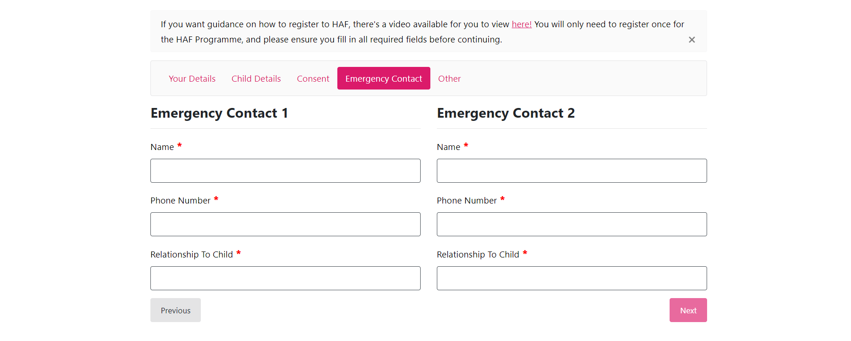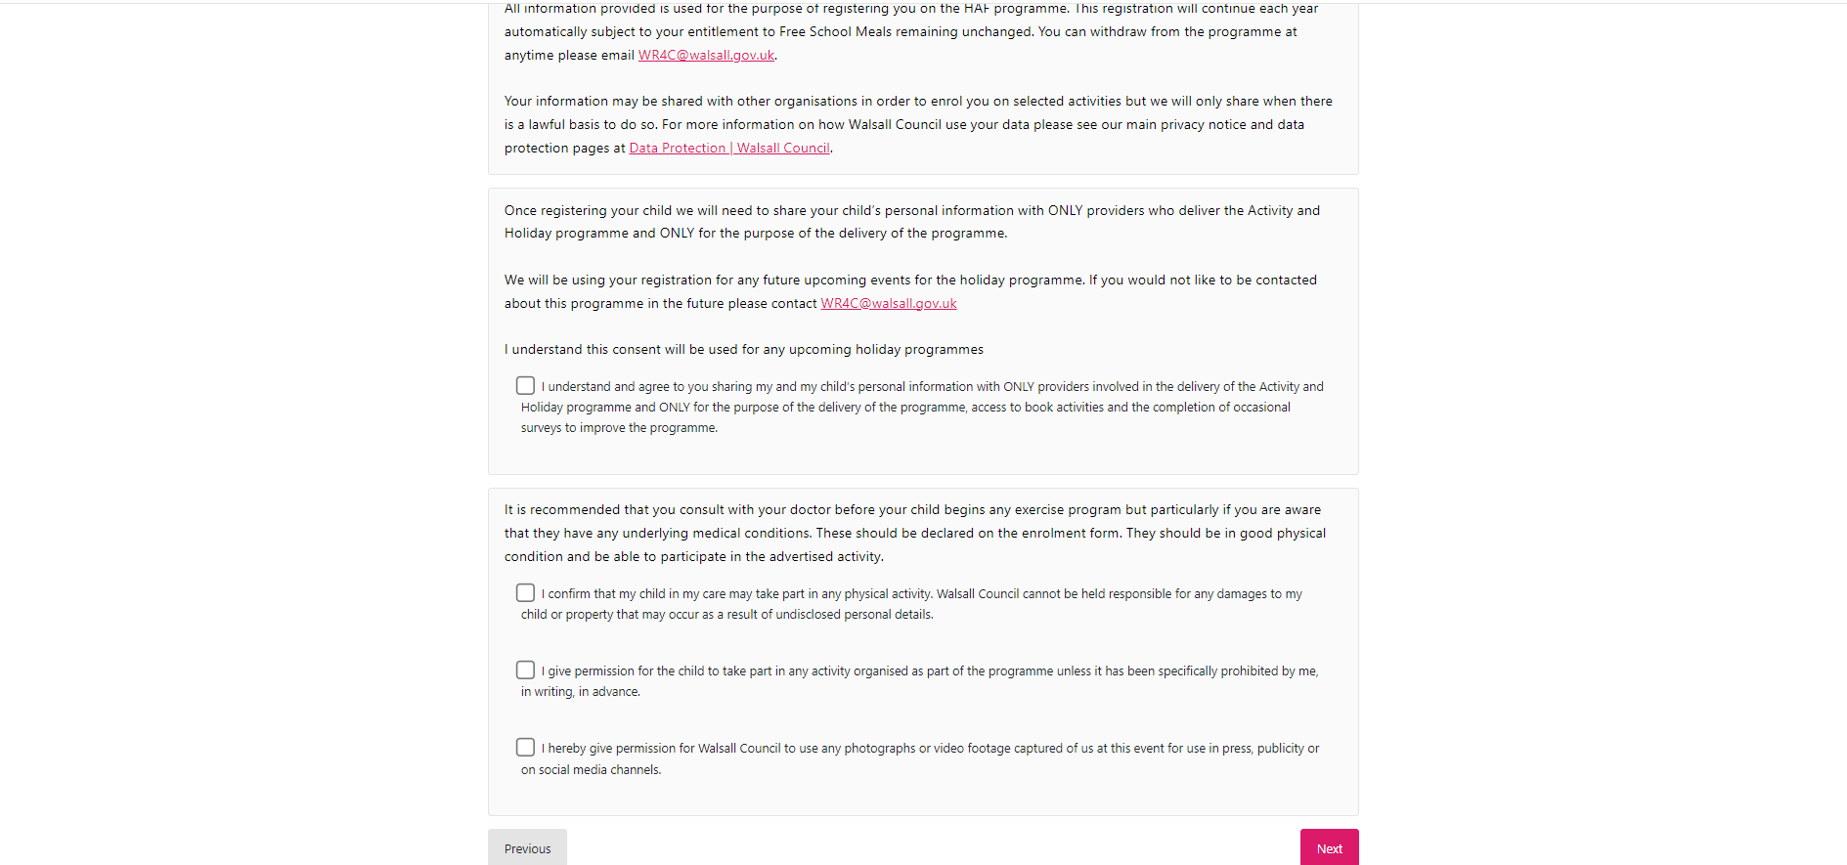For the next part, please read the consent form thoroughly for the first child and tick each box. Then click next. **This will go to the next child or if there is only one child, this will continue to the next part.**

For the next part, please enter two emergency contacts – including their full name, relationship to the child and phone number. You can use the **same emergency contact** for the second contact, but the box must be complete to proceed with the registration. Once this has been completed, click next.

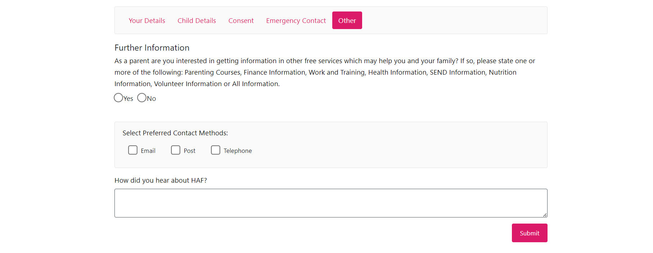For the final part, if you would like to receive any additional information about the free services which might help you and and your family, tick the box and confirm how you would like to receive the information (email, post or telephone). In addition, fill out a brief description of how you heard about the HAF Programme.

If you need digital support or support with regsitration because you have no access to the internet

please see attached our **Digital Venues (you can go to any of these to get support with registering),** but please arrive with your HaF code by emailing us if you don’t have a code at [wr4c@walsall.gov.uk](mailto:wr4c@walsall.gov.uk)

**PLEASE SEE ATTACHED LIST OF VENUES**

To finish click submit and the application will be complete.