MoreLife is excited to share with you a new digital stop smoking service that you can now refer clients to, provided by Walsall Council.
My SmokeFree Life will provide:
- 12 weekly sessions delivered via an app.
- Access to a stop smoking practitioner.
- Up to 12 weeks free NRT delivered direct to their door (if eligible).
The digital programme aligns with NCSCT standards and is designed to create long lasting shifts in behaviour to give patients the tools and support they need to quit smoking. Users will learn how to prepare for a successful quit, how to cope with cravings and track their progress through a personalised dashboard. The flexibility of the app means that the programme information can be accessed at any time with no need to travel to appointments.
To download the app simply scan the QR code or search My Smokefree Life on Apple or Google play Store. One You Walsall will also be able to triage all referrals so you can also still use that pathway so that people get the most suitable stop smoking pathway…



New Digital Service Launches to Help Quit Smoking

My SmokeFree Life in Walsall  MoreLife is excited to share with you our NEW Digital Stop Smoking Service.  To access the free service simply share the QR code below.  Commissioned by Walsall Council, we provide a FREE* 12-week digital stop smoking programme via an app.  Users will also have access to a specialist stop smoking practitioner as well as NRT delivered directly to their door*  *eligibility criteria apply  Break free, breathe easy and embrace a SmokeFree Life | 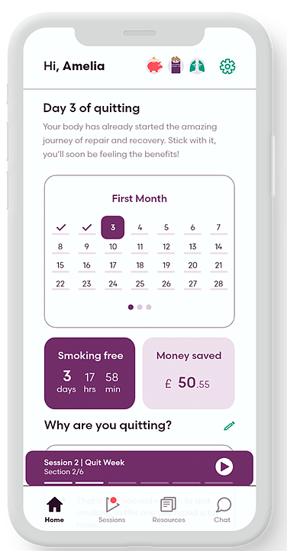
Eligibility Criteria
- 18 years old or older
- Living, working or registered with a GP in Walsall

My SmokeFree Life Walsall
My SmokeFree Life App provides a weekly programme of support, with the option of speaking to a Specialist Stop Smoking Advisor, along with receiving stop smoking treatments direct to your door*.
*eligibility criteria apply
Quitting with support increases the chances of staying smoke free.

CLICK HERE TO FIND OUT MORE

For more information or if you would like to be provided with promotional materials, please contact: mysmokefreelifewalsall@more-life.co.uk

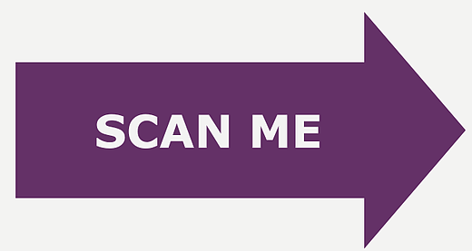  Users can access the free app by scanning the QR code with their mobile phone or by searching My Smokefree Life on the App Store. | 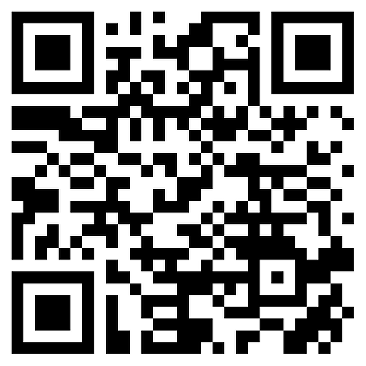


MoreLife, Churchwood Hall, Leeds Beckett University, Headingley Campus, Leeds, Yorkshire LS6 3QJ, 0113 812 5233
Unsubscribe Manage preferences

